

FACULTY OF ENGINEERING

SCHOOL OF COMPUTING

SEMESTER 1/20202021

**SCSP3213: Business Intelligence**

**LECTURER:** Dr. Noorfa Hazlinna Mustafa

**SECTION:** 02

**TITLE:** AA Project Proposal (PlayStore Applications)

**Name:** Aiman Shaquan Bin Mohd Yusof

**Matric No.:** A18CS0021

# Data Background

This data set is about applications in Shopify. The data holds 7 tables in which four of the tables includes the details of the apps such as name, category, descriptions, developers, titles, rating, reviews and etc. Another 2 of the tables consist of price, pricing plans and features. And the last table holds the user’s review of the app such as body, rating, date commented and developer’s reply.

Proper cleaning, analysis and visualizations are crucial for Shopify to be able to see trending applications or games, genres, a highly legitimate functioning apps and also in providing all possible recommendations to the users.

# Information of Data Source

The data set has 2 .csv files which are googleplaystore.csv and googleplaystore_user_reviews.csv

* googleplaystore.csv (contains the data of the applications in the Google Playstore)
  + App – the applications’ name
  + Category – the applications’ category
  + Rating – ratio and summed ratings of user’s reviews
  + Reviews – review counts of the application
  + Size – the memory storage for users to download
  + Installs – counts of the application’s installations
  + Type – the application’s type either Free or Paid
  + Price – the price for the paid type applications
  + Content Rating – which targetted category ages for the applications
  + Genres – the application’s genre and an app can belong to multiple genres
  + Last Update – application’s last update date by the developers
  + Current Version – application’s current version
  + Android Ver – minimum android version for the application to operate
* googleplaystore_user_reviews.csv (contains the data of the reviews of the applications)
  + App – the applications’ name that the review is on
  + Translated_Review – the user’s comment or text review
  + Sentiment – the evaluation of the review whether it’s positive or negative
  + Sentiment_Polarity – the sentiment polarity score in numeric value
  + Sentiment_Subjectivity – the sentiment subjectivity value to the applications

Link for the dataset: <https://www.kaggle.com/lava18/google-play-store-apps>

# ETL Methods

cleaning, selection, join.

|  |  |  |
| --- | --- | --- |
| **File Sources** | **Transformation** | **Component/Implementation** |
| googleplaystore.csv  googleplaystore_user_reviews.csv | Generate id for each app and id for each review | tMap: generate random unique UUID for each |
| googleplaystore.csv | Remove or fill null values with appropriate values | tMap: fill the null value with default value  Relational.ISNULL(column)?default value:column |
| googleplaystore_user_reviews.csv | Transform nan or null string into real null | tMap: fill the null value with real null  Relational.ISNULL(column)?””:column |
| googleplaystore.csv | Change update dates to real date format | tMap: joining the time dimension by TalendDate.addDate(TalendDate.parseDate) |
| googleplaystore.csv  googleplaystore_user_reviews.csv | Merge the table by app id or app name | tMap and tUniqueRow |

# Database Schema

* Star schema

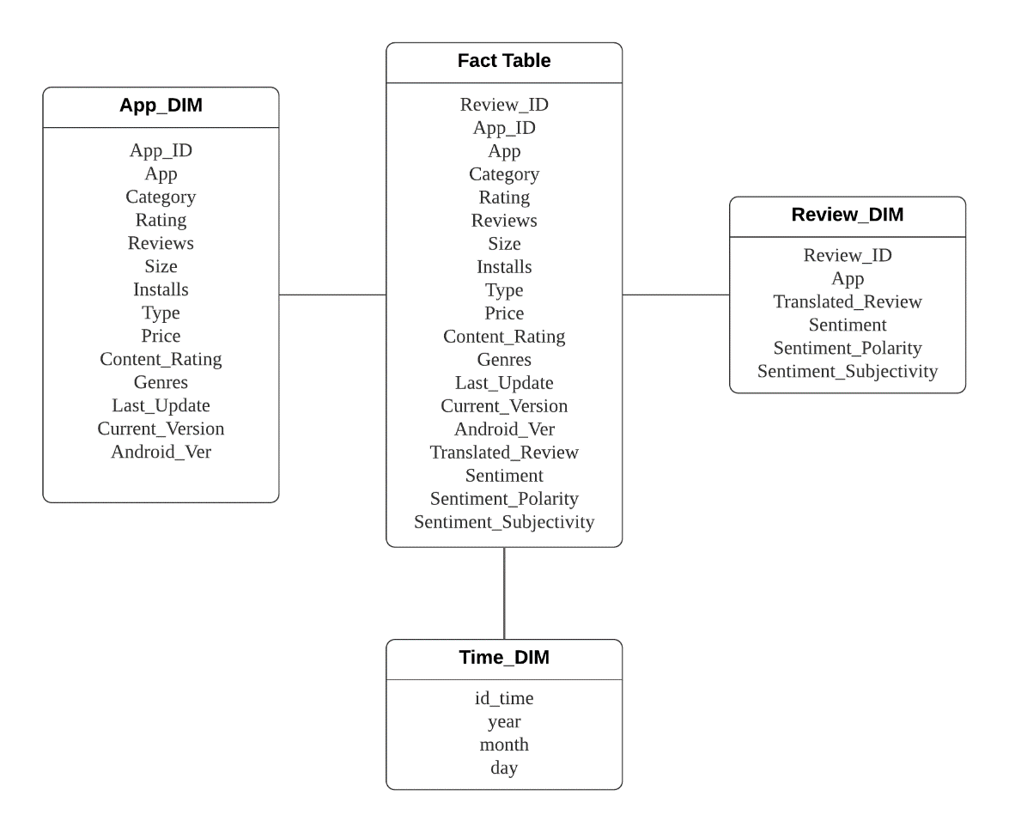

# Chart and Dashboard Design

Charts:

* Line chart of the genre and update date
* Pie chart of the percentage of type and number installs
* Bar chart of rating and by app category and type apps
* Stacked barchart of total installs and total paid/free apps
* Box plot for paid/free apps and average rating
* Treemap of genre and review

Dashboard:

* Dashboard that’d focus on applications installs by using line chart of the genre and update date, pie chart of the percentage of type and number installs, and stacked barchart of total installs and total paid/free apps.
* Dashboard that’d focus on applications review by using bar chart of rating and by app category and type apps, Box plot for paid/free apps and average rating, and treemap of genre and review.